Name_________________________________ Date____________
Mr. Pefanis Characteristics of a Civilization

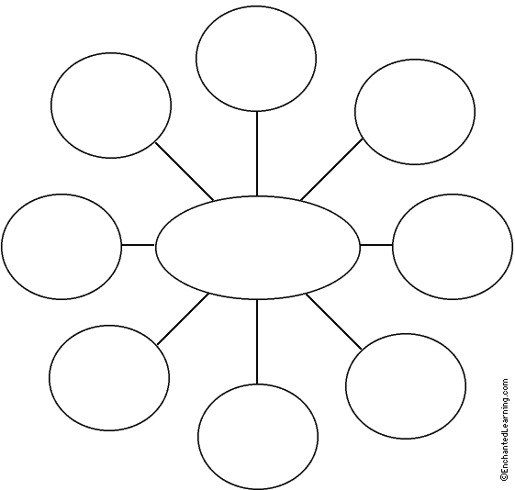
Directions- Along with your teacher complete the notes on the 8 characteristics of a civilization.

