Name________________________ Date__________

Mr. Pefanis Lenin’s Russia

Aim: How did Lenin consolidate and maintain power in Russia after the November Revolution?

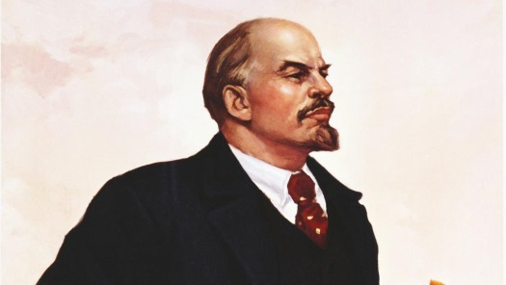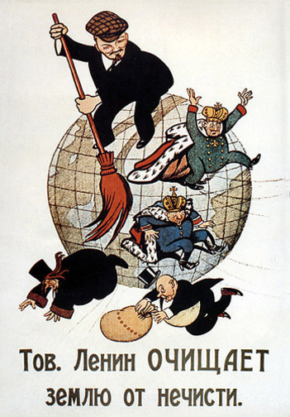Do now- Use the cartoon and quotes to answer the questions below.

A



D

B

“The state is an instrument for coercion … We want to organize violence in the name of the interests of the workers.” Lenin



C

“A good Communist is at the same time a good Chekist*.” Lenin



*Chekist-member of the brutal secret police, execute 50,000 Russians in civil war



Label the following people in the cartoon:



Lenin____ Czar Nicolas II____ Bourgeoisie (Business/Factory Owners)____ Priests____



1. According to the cartoon, what is Lenin doing to the three upper classes of Russia?

2. Which ideas from Lenin’s quotes show that he holds very radical views on government?

**Russian Civil War**

1. Who were the two sides fighting in the Russian Civil War?

2. Who fought on each side?

3. Who intervened on the side of the Czar (Whites)?

4. Who won the war? Why were they successful? (Two reasons-one is a person)



The Evolution of Lenin

**Red Terror**

Shortly after the Civil War began, two assassination attempts were made on Lenin’s life. In response, Lenin ramped up executions of every civilian suspected of being against the revolution, this time period was called the Red Terror. The media was censured, peoples rights were limited and the Cheka (secret police) imprisoned and tortured all who opposed. As the civil war raged on, Lenin became more radical and more determined to control all aspects of the government.

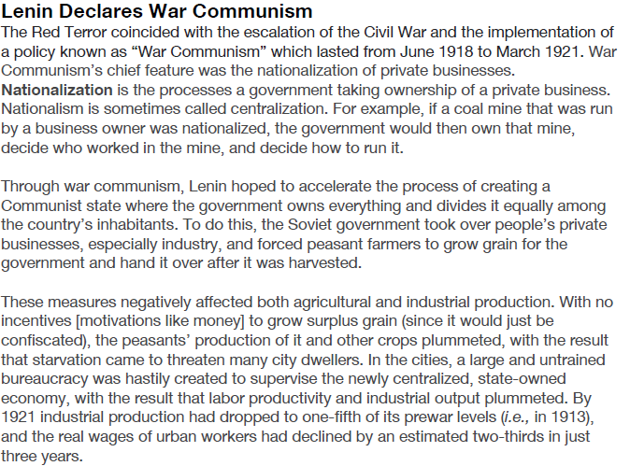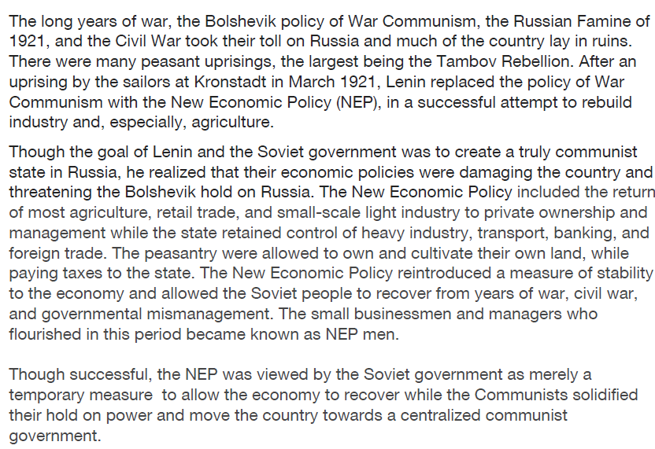Lenin the Russian fighter-War Communism Lenin the Russian leader-N.E.P- New Economic Plan

|  |  |
| --- | --- |
| War Communism  Explain what nationalization does to businesses owned by private owners?  How were grain harvest affected by War Communism?  In the long run, how did War Communism hurt the Russian economy? | N.E.P.-New Economic Plan  Communism is a system of government where all the businesses, land and means of production are managed by the government. How was Lenin’s N.E.P. not a communist plan?  Find two examples from the reading to support your answer above. |
| Big Ideas  How is the policy of War Communism different from the N.E.P.?  When Lenin proposed the New Economic Plan to the people of Russia he explained, “We need to take a step backwards in order to take two steps forward.” What did he mean by this? | |

1. **WHAT POLICIES DID RUSSIA PURSUE UNDER LENIN?**
2. **Lenin’s Chief Goal:**
3. Build a _________________________ where the means of production are in the hands of the people.
4. ________________________ land and people. (Put them under ___________________________ control.)
5. **Government:**
6. ________________________ party, not the ____________________, was in charge.
7. Used the _____________ and ______________________ to maintain power.
8. Created the ______________________________________________ or the ___________________________. Refers to the time when Russia was __________________________.
9. **Lenin’s Plan to Fix the Economy (1921):**
10. Called the __________________________________ (NEP)
11. Allowed some elements of _______________________________.
12. _________________________ controlled big businesses (banks, trade, factories)
13. ________________ business could be ______________________ owned.
14. Helped ________________________ economy and increased standard of living.

|  |  |
| --- | --- |
| **Political System** | **Economic System** |
| Communist Dictatorship | **Command Economy:** government owns and controls everything. Ideas taken from Marx. |
| Democracy | **Capitalism/Free Market System:** Private ownership. Encourages competition. Ideas taken from Adam Smith. |