Name________________________________ Date_________
Mr. Pefanis Causes of Russian Rev

Aim: How was Russia ripe for revolution in 1917?

Do Now- Create a list. What were three things you remember about Russia from last year?

Why Revolution in Russia?

Use the stations readings to answer the questions below

Cause 1- Peasants lives
1. What issues did peasants face after the Emancipation Manifesto in 1861?

2. How could land ownership have changed these issues?

3. Explain how peasants were treated by overseers.

4. What type of food did peasnats eat? How long did they work?

Cause 2- Working Conditions and Bloody Sunday
1. Explain what factory life was like in Russia.

2. Why was 1904 a bad year for Russian workers?

3. How were factory workers tricked by Tsar Nicolas II?

4. How did workers react to Bloody Sunday?

5. Were their problems solved by the Tsar?

Cause 3-Corruption

1. Who was Rasputin? How did he get close to the Romanov Family?

2. How was it believed that he manipulated the royal family?

3. Who saw him as a threat?

4. What happened to Rasputin?

5. What was Rasputin’s prediction to Czarina the Tsar’s wife?

Cause 4- Czar Nicolas II-Military Woes

1. How did Czar Nicolas view his power?

2. Why did he need his secret police?

3. Why were military victories important for the Czar?

4. What were two examples that highlighted Russia’s poor decision making in military decisions?

Cause 5- March Revolution

1. Why do riots flare up in 1917?

2. What does the Tsar order soldiers to do? How do the soldiers respond?

3. What happened to the Tsar?

4. What was the provisional government?

5. What are two examples that highlight the weakness of the provisional government?

Tomorrow!

“Peace, Land, Bread!”
Vladamir Ilyich Lenin

Cause #1: The Peasants’ Lives
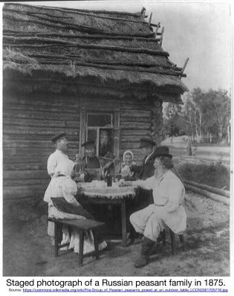
In 1861, Czar Alexander II issued the Emancipation Manifesto, which was a document that freed all of the 23 million serfs in Russia. The newly freed serfs had no money to buy land and most of them were forced to work in poor conditions with little pay without their most basic needs being met. By 1900, around 85 percent of the Russian people lived in the countryside and earned their living from agriculture. These peasants lived in extreme poverty and became disgruntled with the government and the upper class who had money and owned the land.
In the summer of 1876, Praskovia Ivanovskaia and her friend Galina Cheriavskaia went to work as agricultural laborers.The following are sections of Praskovia Ivaovskaia’s recollection of her time:
“At four in the morning, as the sun's rays were just beginning to spill over the steppe, the overseer would wake us, kicking the legs of those who wouldn't get up immediately…. In the morning, we froze from the bitterly cold dew, which drenched our clothing up to the waist. Staggering along, still half asleep, we worked as automatically as robots, gradually warming up a bit.”
“At ten, we returned to camp for breakfast, which lasted around half an hour. Despite the camp hubbub, some people preferred to nap instead of eating. Our food was of rather poor quality - very plain and unappetizing. In the morning, they cooked us a watery gruel made from wheat and water with a dose of salt, or buckwheat dumplings as big as cobblestones - one or two of these would satisfy the hunger of even the greatest glutton. The meal was poured into a wooden trough, from which you'd pull the dumplings with long, pointed splinters. We got the same modest fare for lunch and dinner.”
“After our brief breakfast, we returned to work. As the day wore on, the heat became so intense that you wanted to take shelter in any available patch of shade. The sun was so strong that the backs of most of the newly arrived vagabonds were practically covered with swollen blisters; later, as their skin toughened up, the burns went away.”
“During the busy season, there were no set limits to the work day: if the steward wished, it could last for sixteen hours or more, with only an hour off for lunch…”
“In the evening, after the sun had set, we returned to camp....“Frequently our evening talks ended with the peasants saying: "That's our fate - so it's been written", or, "We're born - we'll die."
“In fact, we were rarely able to talk at all: after the day's work, our limbs shrieked with weariness, our exhausted bodies demanded rest and peace. “

Cause #2: Working Conditions and Bloody Sunday (January 22, 1905)

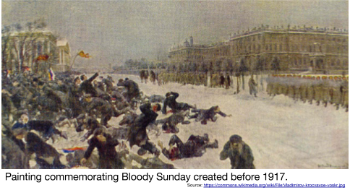
At the beginning of the 20th century the Russian industrial employee worked on average an 11 hour day (10 hours on Saturday). Conditions in the factories were extremely harsh and little concern was shown for the workers' health and safety. Attempts by workers to form trade unions were resisted by the factory owners, and in 1903, a priest named Father George Gapon, formed the Assembly of Russian Workers. Within a year it had over 9,000 members.

1904 was a bad year for Russian workers. Prices of essential goods rose so quickly that real wages declined by 20 per cent. When four members of the Assembly of Russian Workers were dismissed at the Putilov Iron Works, Gapon called for industrial action. Over the next few days, over 110,000 workers in St. Petersburg went out on strike.

In an attempt to settle the dispute, George Gapon decided to make a personal appeal to Czar Nicholas II. He drew up a petition outlining the workers' suffering and demands. This included calling for a reduction in the working day to eight hours, an increase in wages and an improvement in working conditions.

Over 150,000 people signed the petition and on January 22, 1905, Gapon led a large procession of workers to the Winter Palace in order to present the petition to Nicholas II. When the procession of workers reached the Winter Palace, it was attacked by the police and the Cossacks [Russian Soldiers]. Over 100 workers were killed and some 300 wounded. The incident became known as Bloody Sunday.

Bloody Sunday sparked waves of strikes and violence across Russia in support of worker’s rights and against the Czar. The violence following Bloody Sunday became known as the Revolution of 1905. In response, Czar Nicholas II reluctantly promised more freedom and approved of the creation of the Duma, the first parliament in Russia. Nicholas II dissolved the Duma in ten weeks and many of the problems plaguing Russian workers continued.

Cause #3: Corruption in the Czar’s Family: Rasputin (1872- 1916)
 | Born a peasant in Siberia, Grigori Rasputin became a religious teacher, although he was never ordained as a priest. He became close with the Romanov family (Tzar’s) because they believed he had mysterious powers that relieved their son’s hemophilia, a disease that prevents blood from clotting and causes massive bleeding from even slight injuries.  It was rumored that Czarina Alexandra, who was put in charge of the Czar’s responsibilities when he went to command troops during WWI, was heavily under Rasputin’s control. In December 1916, a small group of young aristocrats who feared that Rasputin was taking control of the government plotted his assassination. They lured him to a mansion and fed him poisoned cakes. The poison apparently had no effect on Rasputin’s extraordinary strength. The conspirators then shot him several times. Assuming he was finally dead, they threw him into the Neva River. When his body was discovered three days later, doctors confirmed the cause of his death- drowning.  Rasputin’s death threw the Czarina into shock. His prediction haunted her: “If I die or you desert me, in six months you will lose your son and your throne.”  The specifics behind Rasputin’s death are now more a legend than fact. Many of the facts have been discredited through historical investigation. Rasputin’s supposed influence over the Czar’s family showed that the government was corrupt and added to the lower class’s distrust for the family. | 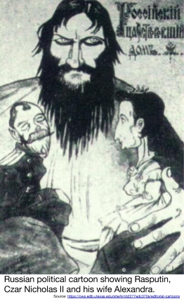

Cause #4: Czar Nicholas II’s Military Woes
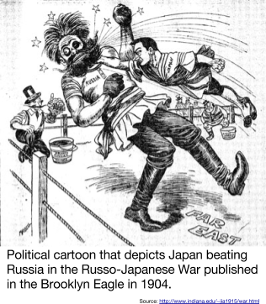
Czar Nicolas was an autocrat who believed he had the divine right to rule from god. He refused to have his power challenged or shared with any group. He used his secret police to spy on the Russian people and murder and torture those who disagreed.
Popular support for a country’s leader has always depended largely on their success as a military leader. Czar Nicholas II experienced several disappointments which turned the peasants and workers against him. The Russo-Japanese War and World War I showed the Czar’s weakness and paved the way for revolution.
In the late 1800s, Russia and Japan were imperialist powers. Both competed for control of Korea and Manchuria. The two nations signed a series of agreements over the territories, but Russia broke them. In retaliation, Japan attacked the Russians at Port Arthur, Manchuria, in February 1904. Though Russian soldiers and sailors went confidently to war, the Japanese defeated them. News of repeated losses sparked unrest at home and led to revolt in the midst of the war.
In 1914, Nicholas II made the fateful decision to drag Russia into World War I. Russia was unprepared to handle the military and economic costs. Russia’s weak generals and poorly equipped troops were no match for the German army. Before a year had passed, more than 4 million Russian soldiers had been killed, wounded or taken prisoner. German machine guns mowed down advancing Russians by the thousands. Defeat followed defeat. As in the Russo-Japanese War, Russia’s involvement in World War I revealed the weakness of czarist rule and military leadership.

Cause #5: The March Revolution (1917)
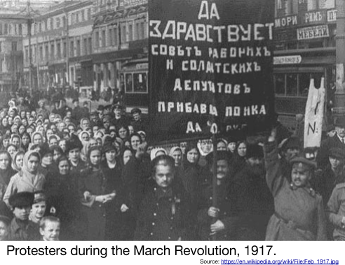
In March 1917, women textile workers in Petrograd led a citywide strike. Soon afterward, riots flared up over shortages of bread and fuel. Nearly 200,000 workers swarmed the streets. At first the soldiers obeyed orders to shoot the rioters but later sided with them. The soldiers fired at their commanding officers and joined the rebellion. Large crowds gathered, shouting “Down with the autocracy!” and “Down with the war!”
The local protest exploded into a general uprising- the March Revolution. It forced Czar Nicholas II to abdicate (give up) his throne. The czarist rule of the Romanovs, which spanned over three centuries, had finally collapsed. The March Revolution succeeded in bringing down the czar, yet it failed to set up a strong government to replace his regime.
Leaders of the Duma established a provisional government, or temporary government. The provisional government kept the country in World War I and was too weak to make the changes that peasants and workers demanded. Staying in World War I was a costly decision that was wildly unpopular amongst the people. Instead, power in the cities grew in local councils of workers called Soviets. In many cities, including Petrograd, the soviets had more influence than the provisional government.
The March Revolution of 1917 dethroned Nicholas II but failed to put a strong government in his place.

