Name_____________________________ Date________
Mr. Pefanis Paleolithic Era

Aim: How did early people live during the Paleolithic Age?

Do Now: Read the cartoon below and answer the accompanying questions.

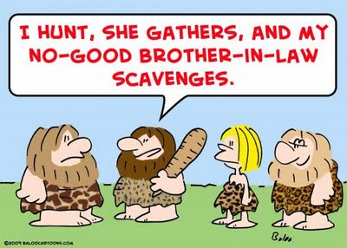
1. According to the cartoon what are three ways that early man collected food and resources?

___________________________________________________________

___________________________________________________________

2. What role(s) did men have in early society? Why do you think men had this role(s) but women did not?

__________________________________________________________________________________________________

__________________________________________________________________________________________________

Activity #1 Directions- You will be working in cooperative groups. Each group will read both scenarios and choose which lifestyle they think is best. Once a choice is made create a T-chart describing the benefits and drawbacks of the lifestyle your group chose best. (Group roles-Leader, writer, and presenter.)

Scenario 1- Bonk is an early human, he is much bigger and stronger than a modern man but has limited capacity to learn. He spends most of his time his time hunting and gathering for food and supplies. Bonk is part of a clan, when he comes home with meat everyone eats. When he comes home empty handed the others share with him. In his clan are about 15 people of varying ages, two of which are infants, one person suffering a life threatening condition and one very weak old man. Although there are no written laws and he is free to leave when he wants he enjoys the safety and company of his clan. The Spring time offers plenty of wild berries and vegetables that can be harvested but as Spring turns into Fall it is harder and harder to find food. To do so Bonk’s clan must roam to new lands, this upsets him because he understands that he will have to compete with other clan’s for resources. Not all clans will be friendly.

Scenario 2- Mr. Pefanis is by no means as strong as Bonk. Among his peers he is physically weaker than most even some of the women, but it is ok because strength is not needed in his world. He ensures his survival and his clan’s through his knowledge. His clan is smaller than Bonk’s, in total there are four; a women and two infants of differing sexes. In return for sharing his knowledge he receives money. He uses this money to buy food and supplies he will most likely never worry about starving to death, but his family has materialistic desires. He dreams of one day exploring the world beyond his town, but how? Much of the world is already “taken” and the others will not allow him to trespass or share their territory. In his world there are rigid rules, and if they are broken he can lose his freedom. Mr. Pefanis worries about breaking these rules because he could even lose his ability to make money, and in this world hunting and gathering is almost always illegal. If he cannot make money, more than likely no one will offer him help.

Paleolithic Age

- Paleolithic Age (Stone Age)-____________________________
_____________________________________________________
Food | Technology
Gender Roles | Culture/Religion
Summary Question- Write a diary entry explaining what it might have been like living during the Paleolithic Age.
____________________________________________________________________________________________________________________________________________________________________________________________________________________________________________________________________________________________________________________________________________________________________________________________________________________________________________________________________________________________________________
Paleolithic Age

I. Paleolithic Age (Stone Age)- era in human history where humans used primitive stone tools.
Food  -Men hunted in groups for animals.  -Women gathered fruits vegetables and roots.  -Early humans were nomadic  - Domesticated (tamed) dogs | Technology  -Speech.  -Use of hands and minds to make tools. Ex.- Spears & fire  -Ability to adapt to new environments. Ex- Wearing animal skins in cold climates
Gender Roles  Egalitarian society- men and women were seen as equal | Culture/Religion  Culture- refers to anything related to a people’s way of life and beliefs. Ex. Religion, dress, gov’t.  -Created clay pottery  -Created cave paintings in  Spain and France  Religion- a set of beliefs concerning the cause, nature, and purpose of the universe  -Belief in the afterlife

